Hanna Bohannon

SQL-1

**PART 1**

~Query~

CREATE TABLE Authors (

AuthorID INTEGER PRIMARY KEY AUTO_INCREMENT,

FullName VARCHAR(50) NOT NULL,

BirthCountry VARCHAR(50) NOT NULL

);

~Data Insert Query~

INSERT into authors(FullName, BirthCountry)

values ("Jane Austen", "England"),

("Charles Dickens","England"),

("Mark Twain", "UnitedStates");

~Run Query~

SELECT * FROM authors

**PART 2**

~Query~

CREATE TABLE Books (

BookID INTEGER PRIMARY KEY AUTO_INCREMENT,

Name VARCHAR(50) NOT NULL,

AuthorID INTEGER,

FOREIGN KEY(AuthorID) REFERENCES Authors(AuthorID)

);

~Data Insert Query~

INSERT into Books(Name, AuthorID)

values ('Pride & Prejudice',1),

('Sense & Sensibility',1),

('The Pickwick Papers',2);

~Run Query~

SELECT * FROM Books

**PART 3**

~Query~

SELECT fullname, name

FROM Authors

JOIN Books USING (AuthorID)

~View Query~

CREATE VIEW AuthorBooks AS

SELECT FullName AS AuthorName, Name AS BookName

FROM Authors

JOIN Books USING(AuthorID)

ORDER BY FullName DESC;

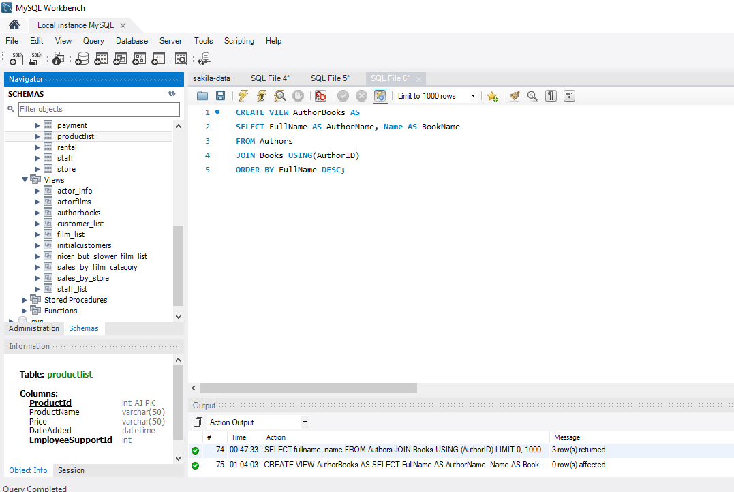

~View Output~

SELECT * FROM authorbooks

